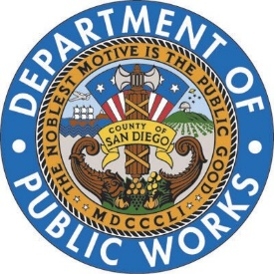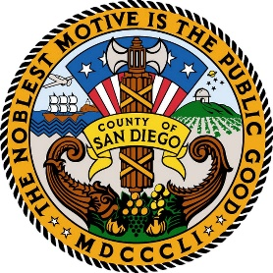**Building Better Roads Workgroup Agenda**

**November 16, 2018 (1 pm to 4 pm)**

**5500 Overland Ave., Room 120, San Diego, CA 92123**

*Mission – Through the establishment of a working group of industry associations and public agencies, with a localized emphasis on the regions resources and the County’s needs, identify means, measures, and methods to improve the quality of regional roads.*

1. **Introductions (1:00 pm – 1:10 pm)**
2. **Public Comments (1:10 – 1:20 pm)**
3. **Overview (1:20 pm – 1:30 pm)**
   * + - 1. Scope
         2. Schedule
         3. Participation and Rules of Engagement
4. **Public Agency Program Presentations (1:30 pm – 2:20 pm) (10 minutes each)**
   * + - 1. County of San Diego
         2. City of San Diego
         3. Caltrans District 11
         4. City of Escondido
         5. City of Chula Vista
5. **Reclaimed Asphalt Products (RAP) (2:20 pm – 2:50 pm)**
   * + - 1. Stockpiles – Matt Pound
         2. Increasing the % of RAP in HMA mixes – Brandon Milar
6. **Resources (2:50 pm – 3:10 pm)**
   * + - 1. Aggregates (Sustainability/Permitting) – Barry Coley
         2. Oil Supply Challenges in California – Jim Ryan
         3. Trucking
         4. Labor shortages
7. **Contracting Methods (3:15 pm – 3:30pm)**
   * + - 1. Benefits to Uniform Mix Designs – Barry Coley
8. **Next Steps** **(wrap up) (3:30 pm – 4:00 pm)**
   * + - 1. Topics for sub-working groups,
         2. Develop and Assign Work Sub workgroups
         3. Action items and next meeting date(s)