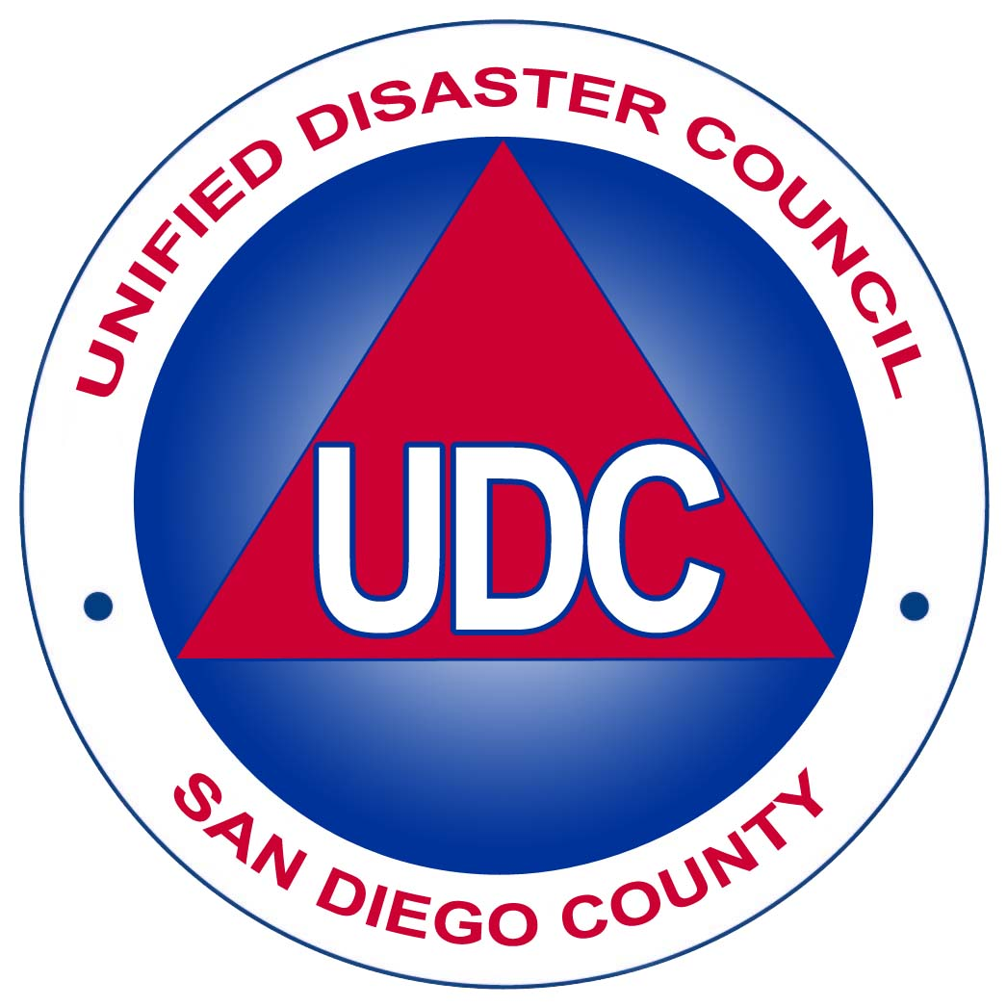
SAN DIEGO UNIFIED DISASTER COUNCIL MEETING
OPERATIONAL AREA EMERGENCY OPERATIONS CENTER
1600 Pacific Highway, CAC, Rm 302-303, SAN DIEGO, CA 92123

February 15, 2007
9:00-11:00 a.m.
AGENDA
Page 1

AGENDA ITEM COMMENTS RECOMMENDED ATTACHMENTS
BY ACTION

1. Call to Order Chair None None

2. Roll Call Ron Lane, OES

3. Presentation of Awards Chair Action as Necessary None

4. Call for Public Input Chair Action as Necessary None

5. Approval of Chair Approval of Minutes I. UDC Minutes of
Minutes December 14, 2006

6. Full Scale Exercise Ron Lane Approval of Exercise Handout
Update OES
7. Urban Area Security Jill Olen, San Diego Approval of Strategy Handout
Initiative (UASI) City
Strategy Update
8. 2007 Homeland Ron Lane, & Approval of Application Handout
Security Grants John Wiecjorek, OES Processes
(SHSG & UASI), Jill Olen, San Diego
9. Regional Vehicles David Harrison, Approval of MOA None
Update San Diego
10. Novelty Lighter David Ott, Del Mar/ Approval in Concept II. Staff Support and Solana Beach Ordinance
Gary Fisher, Vista

11. Regional Caches David Ott, Information Only None
Del Mar/ Solana
Beach
12. SDCFCA Strategic David Ott, Information Only None
Plan Update Del Mar/ Solana
Beach
13. Technology Bob Welty, Information Only None
Partnerships San Diego
Update
14. Evacuation Committee Ron Lane, Information Only None
Update OES
15. Public Education Leslie Luke, Information Only None
Campaign Update OES
16. 3C’s Open House John Lackmann, Information Only Handout
OES

SAN DIEGO UNIFIED DISASTER COUNCIL MEETING
OPERATIONAL AREA EMERGENCY OPERATIONS CENTER
1600 Pacific Highway, CAC, Rm 302-303, SAN DIEGO, CA 92123
February 15, 2007, 09:00 A.M. – 11:00 A.M.

AGENDA, Page 2

AGENDA ITEM COMMENTS RECOMMENDED ATTACHMENTS
BY ACTION

17. Executive Report Ron Lane,
OES

A. SONGS Update Information Only None

B. Mass Notification Information Only None
System Update

C. ICS Courses (300/400) Information Only None

D. Other Information Only None

18. Schedule Next Chair April 19, 2007
Meeting 9:00 – 11:00 A.M.,
5555 Overland Ave.

19. Close Meeting Chair Adjourn None

ASSISTANCE FOR THE DISABLED:
Agendas and records are available in alternative formats upon request. Contact the Office of Emergency Services at (858) 565-3490 (voice) or (619) 531-4803 (TTY). Assistive Listening Devices (ALDs) are available from the Clerk of the Board in Room 402 prior to the meeting, and are to be returned at the end of the meeting. Individuals requiring sign language interpreters should contact the American with Disabilities Coordinator at (619) 531-5205, in advance of the meeting so that arrangements may be made. An area in the front of the chamber is designated for individuals requiring the use of
Wheelchair or other accessible devices.

